The Reserve at Canyon Hills Board Meeting Minutes

Location: Zoom

Date 7/30/2024 5:34PM

ATTENDEES: Nick, Siana, Ashley, Nicole, Destiny, Ashley, The community

Agenda: Street Parking,Pond Efforts,Financial report from Treasurer,Stop Signs,Management,Compliance reporting,Community Q&A,Elections,Nominations,Closing remarks

Minutes:

Parking: parking is prohibited everywhere except for in driveways and in garages, to enhance safety. Homeowners should extend their driveways if they need more space. Guests can be exempted by placing them on the no two list (link on website thereserveatcanyonhills.com) with 48 hours lead time.

Ponds: ponds have been deemed by city of charlotte as out of compliance due to lack of plantings. Efforts were made to get more context on this, which resulted in the reduction in the requirements and a subsequent reduction in the price quote. The latest quote received was for about $80,0000.

Finances: $132,000 is our current balance. Month of June had $29,000 in expenses. Dues will need to be raised to $500 in order to cover our expenses, which have increased significantly in the past 5 years. If we do not increase dues, we will not be able to operate longer than 6 months into 2025.

Stop signs: speedhumps are very cost prohibitive, we are testing the efficacy of installing stop signs at straightaways throughout the neighborhood to curb speeding.

Management: two tier structure: board members and then the management company. AMG is our current management company. To ensure that we were as well equipped as we can be, were accepting bids from other management companies. While we cannot give an update right this moment, we will be sure to share this decision if at all one is made.

Compliance: The following were the documents that Nicole discussed during the compliance briefing:

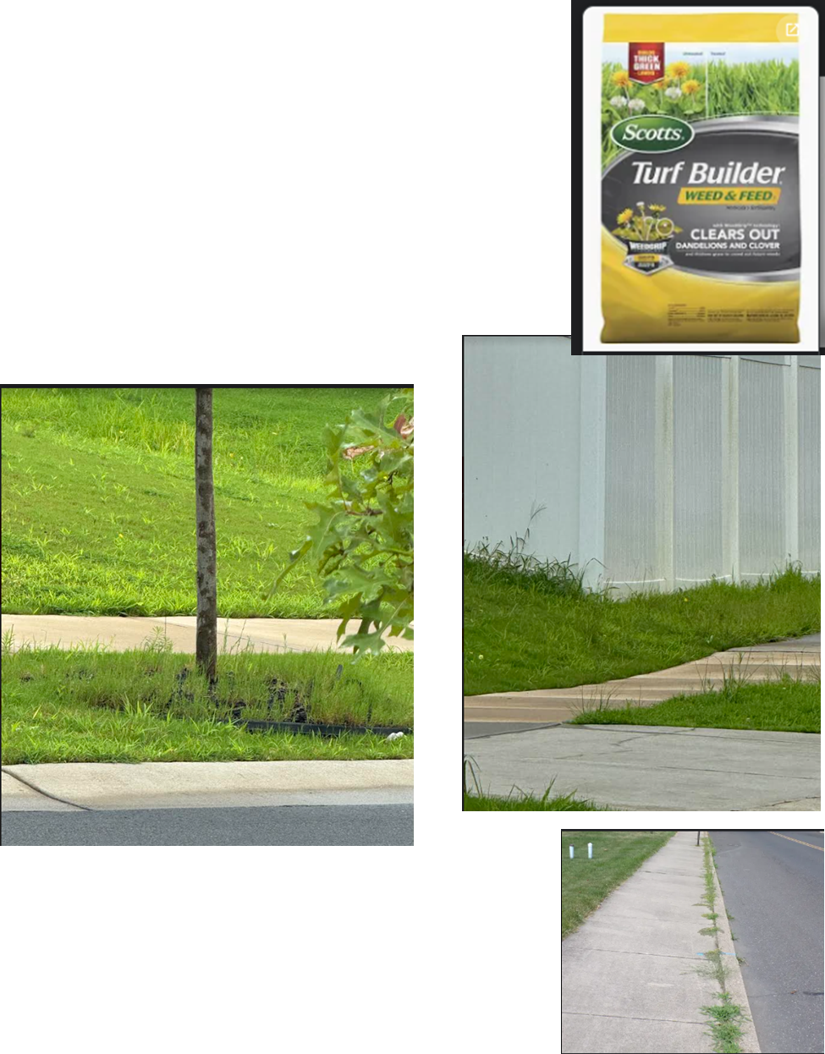

**COMPLIANCE**

* No trailers
* No rigs
* No weeds in the beds; apply fresh mulch or straw.
* Edge sidewalk and driveway and road
* Edge around fence
* Mow lawn to look neat and attractive.
* No erosion: if you have a dirt yard, establishing grass is required.
* Use fertilizer – works amazingly on Bermuda!
* It’s your responsibility to maintain the sidewalk and the road.
* No weeds in the road along the curb
* No weeds in the driveway
* Trash cans cannot be stored on the side of the home.
* **ARCHITECTURE**
* In order to have a shed, you have to have a privacy fence FIRST.
* Sheds cannot have a metal roof.
* Sheds must be a ’mini’ home; so, include a picture of your home.
* If your vendor provided you with an estimate, include it.
* Plat maps and pictures ARE required.

**Any changes to the outside of your home or lot**

**require *prior* Architecture Approval**

[**https://www.thereserveatcanyonhills.com/services-7**](https://www.thereserveatcanyonhills.com/services-7)

The following was a document referenced in the call.

Q&A

S. Laury: Increase in dues; are outstanding accounts receivables considered when the assessment was raised?

Destiny: <10% of the neighborhood have yet to pay dues, these are in collections

S. Laury: Are certain phases picked when improvements are selected:

Destiny: additions are made impartially

S. Fox: How many days are given to remediate and an issue when a violation is sent? (emphasizes proof of violation)

Nicole:

S. Fox: Stop signs. States that people are not making a full and complete stop at the installed stop signs on creedmore and Lanza.

Nicole: Tree impacting visibility is a valid point which should at least be assessed for efficacy, by CMPD

S. Fox: Parking; are there any emergency options for submitting no tow request?

Siana: there are not many viable options to properly accommodate emergency requests. This is a legitimate need that should be addressed.

Lonnie: Concerned about dog parks.

Nick: contract secured with Duty Calls to collect waste.

Lonnie: Will the dog park be moved to somewhere else?

General: it’s not certain whether or not the is the responsibility of the builder, but regardless s

Ibrahim: Was do the duke power line items account for? Is there a breakdown somewhere of these 29,000 that are due every month?

Nick: Cost to power streetlamps, meters, and other equipment in the neighborhood.

Nicole: The City of Charlotte used to have a program where they would take over light bills. The program has been since cut from the budget.

Jonathan: Luttrell: Are vendors being assessed for landscaping?

Vendors were assessed and other options were pricier.

B: Can the increase be spread across two years?

Destiny: dues should be raised now

Evric: How long will the assessment be before determining signs are needed.

Nicole: We need to wait at least 30 days to see if there is an improvement. If there is, we will add 1 intersection at a time.

Nick: We need to gather feedback from the community members that live nearby to fully understand if this had a better outcome vs installing speedbumps. I am certain that relative to the price of a single speedbump it outperformed speedbumps in terms of reduction in speed.

AMG Note:

www.myamgconnect.com is the community portal. If you need assistance with the portal, please email ashley.rammacher@amgworld.com.

Homeowner comment: *And I think a pic should come with the offense to confirm you have the correct home.*

Response: This would be ideal, but at present this is a ‘premium’ feature that AMG offers. Other management companies probably offer this as a default aspect of their inspections.

Annette Webb: Do we have to have as many ponds as possible?

The ponds are necessary to collect stormwater. Water would pool and flood otherwise. LGI was required to construct the ponds.

Pixel 7 Pro: What is the New HOA fee.

HOA Board: $500

Homeowner Comment: *There have been many concerns from the neighborhood wishing to switch management companies because of their experience with them thus far.*

Evric Over 600 homes and we need to raise dues to $500?

Yes. Expenses over the past 5 years have increased, the ponds need to be repaired to get them into compliance. The last quote we received for these repairs was $80,000.

S. Fox: Are the hoa fees increasing for what is due for 2025 or after?

2025.

Taylor: What happens if the HOA doesn’t have enough money to operate? Is it dissolved?

Common spaces are not maintained, grass is not cut, streetlamps turn off home values significantly decrease.

Mcknike: Can we get a breakdown of the current monthly bills? You breezed over the $29k, but little to no explanation.

The 29k value was explained while going over the monthly expense report, which described the 29k due across all of our vendors, which primarily were landscaping, and management fee.

Taylor: How come in the portal the most recent financials posted are 6/30/2023?

This would be answered by Ashley Rammacher.

Taylor: What’s our YTD expense so far?

May I confirm how regularly are HOA meetings? I feel like I hadn't received a notification about one for over a year until this annual meeting notification.

Board meetings have historically been held twice a month. Board meetings with the management company are held once a month.

B-Rush10: What is the response to more households not paying the fees once they are raised?

Accounts in delinquency are sent to collections, which have the potential to turn into foreclosure.

RoCheryl P: Is the need for an increase a direct result of the deficit?

Nick: there are a number of reasons why dues have to be increased, including a deficit in the budget.

Pat: are the stop signs not the responsibility of the city? or is it because they have not been turned over?

The street signs are not paid for by the city.

Tamara H: Why can’t we have In person meetings?

Does not work for board members, we have 650 homeowners. it’s been raining.

Meeting called to end at 9:04PM.